Sales Analysis (using SQL)
Name: Maitreyee Khachane
Course: Data Analytics
Batch: CX-167-MOR-JAN-OFFLINE

1. Project Overview
The objective of this project is to analyse sales data to gain insights into customer behaviour, product performance, sales trends, and revenue generation. The analysis aims to support business decision-making by identifying key patterns, including high-performing products, valuable customers, and market demand, across different regions.

2. Dataset Summary
The dataset consists of five tables:
- Customers – Contains customer details such as name, city, and signup date.
- Products – Includes product information like category and price.
- Orders – Stores order details with order dates and customer IDs.
- Order_Details – Contains product-wise order quantity.
- Payments – Includes payment amount and payment modes.

3. Data Preparation using SQL
- Imported CSV files into SQL Server using BULK INSERT
- Verified data integrity using SELECT queries
- Ensured proper column data types and structure
- Checked relationships between tables using joins

4. Data Analysis using SQL
Total customers– Calculated the total number of customers to understand overall business activity.
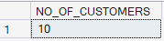
Customer distribution – Identified distinct cities to understand the geographical spread of customers.
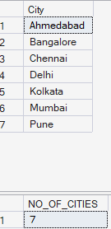
Customer Orders – Mapped customers with their orders to analyse purchasing activity.
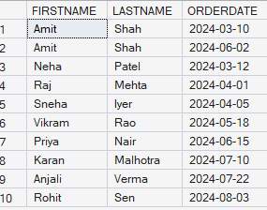
Order Revenue – Calculated revenue generated per order to evaluate earnings. 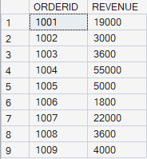
Category Performance – Analysed revenue contribution by product category.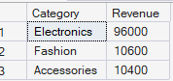
Regional Demand – Identified cities with the highest number of orders. 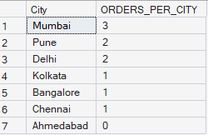
Top Customers – Ranked customers based on total spending to identify key contributors. 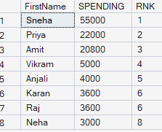
Product performance – Identified fast-moving products based on quantity sold.
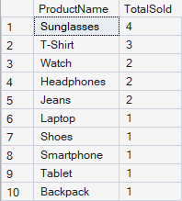
Payment preferences – Analysed the most used payment modes among customers.
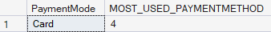
Customer Segmentation – Classified customers into Gold, Silver, and Bronze based on spending.
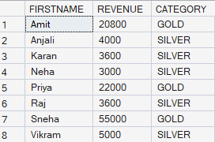
High Value Orders – Identified orders with revenue higher than average. 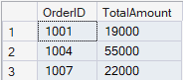

5. Business Insights
- Total customers – Total of 10 customers analysed across 7 cities, showing a geographically diverse customer distribution.
- Product categories – Electronics, Fashion, and Accessories dominate. The electronics category (smartphones, laptops, etc.) contributes the highest demand and revenue.
- Pricing insight – Average product price is approximately 10540, indicating a mix of mid-range and high-value products.
- Sales trend – Orders are consistently placed across months
- Top products – Some products are fast-moving while others remain unsold, highlighting scope for inventory optimisation.
- Regional demand – Certain cities generate higher order volumes, such as Mumbai, showing higher demand concentration.
- Revenue drivers – Electronics category generates higher revenue
- Customer behaviour – A small group of customers contributes significantly to total revenue, indicating high-value customers.
- Payment preference – Digital payment methods are widely used
- Engagement – Few customers remain inactive or without orders

7. Conclusion:
The analysis provides valuable insights into customer behaviour, product performance, and overall business trends. The business demonstrates a strong presence across multiple cities with a diverse product portfolio. Electronics emerge as the most significant contributor to revenue, while certain customers play a key role in driving sales. The presence of both active and inactive customers highlights opportunities for targeted engagement strategies. Additionally, identifying high-performing products and high-value transactions can help optimise inventory and pricing decisions. Overall, the insights derived from the analysis can support better decision-making, improved customer targeting, and enhanced business growth strategies.

